**Iot Based Safety Gadget For Child Safety Monitoring & Notification**

PANIMALAR INSTITUTE OF TECHNOLOGY

MEMBERS:

1) Mithra shree.K.R

2) Ann Maria Fredy

3) Swethapriyaa.S

4) Tejaswini.G

**DATE:18/11/2022**

ACKNOWLEDGEMENT

We would like to thank Mrs.Kalaiarasi.D, our professor-in-charge for their support and guidance in completing our project on the topic IoT Based Safety Gadget for Child Safety Monitoring & Notification. It was a great learning experience.

I would like to take this opportunity to express my gratitude to all of my group members Mithra shree.K.R, Ann Maria Fredy, Swethapriyaa.s, Tejaswini.G. The project would not have been successful without their cooperation and inputs.

**TABLE OF CONTENTS:**

1. Abstract
2. Introduction
3. Literature survey
4. Ideation and proposed solution
5. Requirement analysis
6. Project design
7. Project planning and scheduling
8. Coding and solutioning
9. Testing

10.advantages and disadvantages

11.conclusion

12.futures scope

13.appendix

**1.ABSTRACT:**

The overall percentage of child abuse cases filed nowadays in the world is about 80%, out of which 74% are girl children and the rest are boys. For every 40 seconds, a child goes missing in this world. Children are the backbone of one's nation, if the future of children was affected, it would impact the entire growth of that nation. Due to the abuse, the emotional and mental stability of the children gets affected which in turn ruins their career and future. These innocent children are not responsible for what happens to them. So, parents are responsible for taking care of their own children. But, due to economic conditions and aims to focus on their child's future and career, parents are forced to crave for money. Hence, it becomes difficult to cling on to their children all the time. In our system, we provide an environment where this problem can be resolved in an efficient manner. It allows parents to easily monitor their children in real time just like staying beside them as well as focusing on their own career without any manual intervention.

**2.INTRODUCTION:**

The internet of things (IoT) refers to the set of devices and systems that stay interconnected with real-world sensors and to the internet. For years’ Child safety has been under threat and it is very important to provide a technology-based solution which will help them under panic situations and monitor them using a smart gadget. The proposed system is equipped with GSM and GPS modules for sending and receiving calls and SMS between safety gadget and parental phone, the proposed system also consists of Wi-Fi module used to implement IoT and send all the monitoring parameters to the cloud for android app monitoring on parental phone. Web application can be used to track the current location of a safety gadget using its location coordinates on the parental phone android app and also via SMS request from parent phone to safety gadget. Panic alert system is used during panic situations and automatic SMS alert and phone call is triggered from safety gadget to the parental phone seeking for help and also monitored for plug and unplug from hand, as soon the gadget is unplugged from hand a SMS is triggered to parental phone and the alert parameter is also updated to the cloud.

Heart-beats, temperature is monitored and the values are updated to cloud continuously for parent app monitoring. Boundary monitoring system is implemented on safety gadgets with the help of BEACON technology, as soon as the safety gadget moves far away from the binding gadget an alert is provided to the parent on the binding gadget. The system is used to monitor the health parameters and also used for location tracking during necessary situations in safety concerns.

**3.LITERATURE SURVEY:**

1. **Embedded IEEE Project Child Safety Wearable device:**

The concentration of this paper is to have an SMS content empowered correspondence medium between the children wearable and the parent as nature for GSM portable that correspondence is practically present all over the place. The parent can send a content with particular catchphrases, for example: area, temperature, uv, sos, buzz and wearable gadgets will answer back with a content containing the continuous exact area of the youngster which after will give applications.

**B. Child safety wearable device:**

The child safety device is capable of acting as a capable IOT device it provides parents with the real time location, surrounding temperature, UV radiation index and SOS light along with distress alarm buzzer for their child’s surroundings and the ability to locate their child or alert bystanders in acting to rescue or comfort the child. The smart child safety wearable can be enhanced much more in future by using highly compact arduino modules such as the lily pad arduino which can be sewed into fabrics. Also a more power efficient model will have to be created which will be capable of holding the battery for a longer time.

**METHODOLOGY:**

The Node RED , IBM Cloud, is the brain of our system. All of the nodes and world maps in this room are linked to connections. Using the python language, the node is programmed to do the following functions.New system will be based on “IOT” It will consist of a web based monitoring system. The Node Red collects various types of data from the different modules interfaced to it, such as the GPS module upon being triggered.Alert SMS to Caretaker,Nano to retrieve the live GPS location using the GPS module via serial connection, process the GPS data, and communicate the live location coordinates to the caretaker by SMS using the GSM module. A call will also be made to the caretaker using an automated system. This GPS allows us to make Geofence around the area in which the parent wants to surround them. This Geofence alerts the parents in case the children are out of that limited area.

**EXPERIMENTATION:**

This work attempts to tackle a social concern that has been destroying the lives of uncountable individuals and their families. This device continuously monitors the individual wearing it, the data being accessible world over enabled by the benefits of cloud computing. The data can thus be downloaded onto any remote station for monitoring and analysis. The machine learning algorithms used make the device intelligent and the accuracy of which increases with continued use. A device like this improves the level of safety of children and girls. Accurate recognition of a dangerous situation is a complex matter, however, the scope for improved accuracy is promising.Specific alert system is also added in addition to tracking.

**OUTCOMES:**

IOT is getting upgraded day by day and its security is also upgraded. In this proposed system, we are mainly focusing on child remote monitoring system also we are using the radar devices as well as obstacle sensors which will detect the alert when the child enters the danger zone or else he/she is approaching towards harmful object then alert will be given to the caretaker through the mobile using an alarm or notification. For sensing purpose we are using Waterproof Ultrasonic Obstacle Sensor which are placed in the simple locket that is given to the baby so that locket will give alert to the caretaker through the mobile and for battery backup we are using solar panel through which the energy will get stored in the care taker’s shoes and this energy will be dependent on the steps covered by the caretaker. In this proposed system a general method for rapid peak detection is used for depth/height measurement. First, the signal curve is equally divided and maximum and minimum values in each segmentation are collected. The repeated maximum and minima values are removed and all fake peaks are merged in the case of ensuring true peaks remain. Experimental results showed that: compared with traditional methods, the proposed method is more accurate and faster in peak detection, and suitable for a variety of waveforms.

**3.1RELEVANT REFERENCES:**

1. Akash Moodbidri, Hamid Shahnasser, “Child safrty wearable device,”in IEEE Xplore, June 2017.

2. Child safety wearable device Gopinadh Jonnadula1, Bhanu Prasad Davu, Hari Kishore Kandula, Vinod Donepudi, sivaiah Etukuri Student of ECE, VVIT, Guntur, Andhra Pradesh, India. International Journal for Research in Applied Science & Engineering Technolgy(IJRASET). Volume 6 Issue II, February2018.

3. Jatti, Anand & Kannan, Madhvi & M Alisha, R & Vijayalakshmi, P & Sinha, Shrestha.2016. Design and development of an IOT based wearable device for the safety and security of women and girl children.

4. Asmitha pawar, Pratiksha sagare, Tejal sasne, and kiran shinde “Smart security solution for women and children safety based on GPS using IOT”volume2 issue 3march 2017, International Journal of recent innovation in engineering and research.

5. Design and implementation of child safety monitoring system Archana.R, Priyadharshini.A, Sathish Kumar.R, Subashini.R IV-year/Department of ECE mr.R.Arun Prasath[1] AP/ECE Excel College of Engineering and Technology International Journal volume 6 issue 1.

6. Zhigang gao, Hongui guo, Yunfeng xie, and yanjun luo, Hangzhou dianzi university. “Child guard a child- safety monitoring system”, hujiuan lu and keyan, china jiliang university, 2017 IEEE.

7. Ilhan˙ Ilhana,˙Ibrahim Yıldıza1,Mehmet Kayrakb,2 , Development of a wireless blood pressuremeasuring device with smart mobile device, computer methods and ptogram in bio medicine (2016) 94-102.

8. M.Pallikonda Rajasekaran, R.Kumar .An IOT based patient monitoring system using Raspberrypi , IEEE International Conference on Computing Technologies and Intelligent Data Engineering (2015),pp. 1-4.

9. A. Visvanathan, R. Banerjee, A.D. Choudhury, A. Sinha, S.Kundu, Smart phone based blood pressure indicator in:Proceedings of the 4th ACM MobiHoc Workshop onPervasive Wireless Healthcare, August, ACM, 2014,pp. 19–24.

10. C.A. Gomez Pachon, M. Valderrama, F. SeguraQuijano,Design and implementation of a wireless tensiometer withsmartphone interface, in: Health Care Exchanges (Pahce),Pan American, 2013, pp. 1–3.

11. Chandrasekaran, R. Dantu, S. Jonnada, S. Thiyagaraja, K.P.Subbu, Cuffless differential blood pressure estimation usingsmartphone, IEEE Trans. Biomed. Eng. (2013)1080–1089.

12. Doss, Pradeep, S. N. Siva, and Madhu Sudhan. "Non-invasive health monitoring system for infants using IOT." 2019 1st International Conference on Innovations in Information and Communication Technology (ICIICT). IEEE, 2019.

13.. Badgujar, Dipali, Neha Sawant, and Dnyaneshwar Kundande. "Smart and secure IoT based child monitoring system." Int Res J Eng Technol (IRJET) 6.11 (2019).

14. Joshi, Madhuri P., and Deepak C. Mehetre. "IoT based smart cradle system with an Android app for baby monitoring." 2017 International Conference on Computing, Communication, Control and Automation (ICCUBEA). IEEE, 2017.

15. Mandke, Shilpa, et al. "IOT based Infant Health Monitoring System." International Journal of Engineering and Technology (IRJET) (2018).

4.IDEATION AND PROPOSED SOLUTION:

4.1 EMPATHY MAP :

An empathy map is a collaborative tool teams can use to gain a deeper insight into their customers.

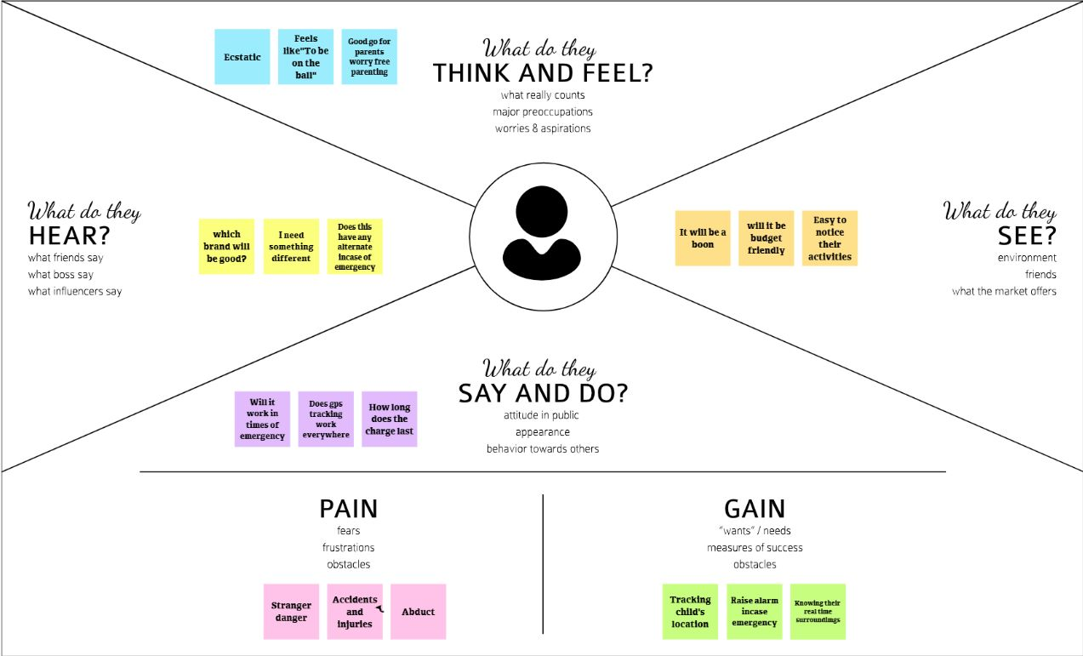

4.2 BRAINSTORMING AND IDEATION:

Brainstorming is a method of generating ideas and sharing knowledge to solve a particular commercial or technical problem, in which participants are encouraged to think without interruption. Brainstorming is a group activity where each participant shares their ideas as soon as they come to mind.

|  |  |
| --- | --- |
| Group member-1: | Group member-2: |
| Group member-3: | Group member-4: |

4.3 PROPOSED SOLUTION:

Proposed solution should relate the current situation to a desired result and describe the benefits that will accrue when the desired result is achieved.

1.PROBLEM STATEMENT:

The increasing need for protection of the child at present times and also when child can be lost in crowded areas. Using Bluetooth and Wi-Fi not possible to track larger distance.

2.Solution description:

Wearable gadget which tracks health conditions of the child using temperature, heartbeat and accelerometer sensor and sends notifications to parents about child’s health conditions through android mobile application.

3.Uniqueness:

Real-time location tracking and integrate all the features offers by the existing system such as GPS Tracking, Sos. The application requires an initial registration along with emergency contact of user and they asked to update time to time. Whenever user is travelling from one place to another.

4.Customer Satisfaction:

This gadget helps to monitor heartbeat, raise alarm in case of emergency, track the current location ,quick updation of child movements, overall these features makes the parents Stress Free.

5.Business Model :

It helps to reduce their vulnerability in harmful situations. It also means protecting children against social, psychological and emotional insecurity and distress.

6. Scalability of the Solution:

Quantitative and qualitative attributes of scaling up and that effective scaling up initiatives need to be adaptable, sustainable and successful in achieving their objectives. The importance of incorporating monitoring and evaluation throughout the scaling-up process is physical spread of activities, structures or materials described.SO physical spread of activities, structures or Materials.

4.4Problem solution fit:

The Problem-Solution Fit simply means that you have found a problem with your customer and that the solution you have realized for it actually solves the customer's problem.

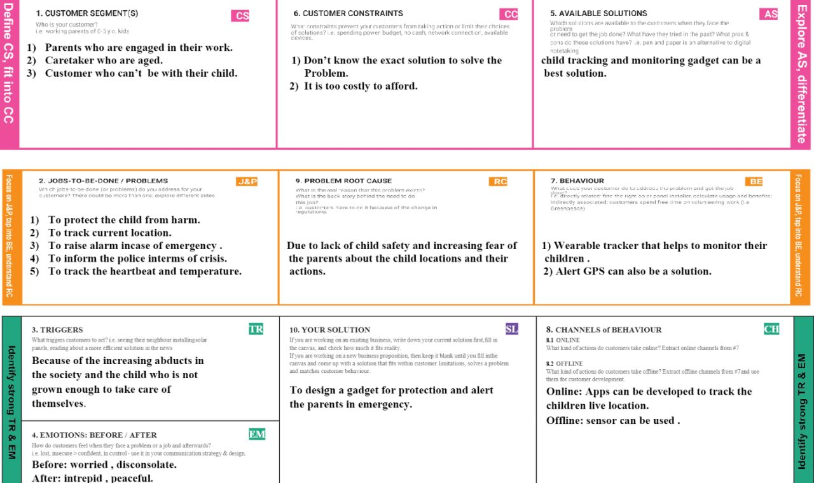

5.REQUIREMENT ANALYSIS:

5.1FUNCTIONAL REQUIREMENT:

|  |  |  |
| --- | --- | --- |
| FR No. | Functional Requirement (Epic) | Sub Requirement (Story / SubTask) |
| FR-1 | Temperature | If the temperature level exceeds the room temperature then the alert message will be sent using GSM to the specified users. |
| FR-2 | Pulse sensor | The Pulse sensor is used to detect any abnormal feelings experienced by the child like fear, anxiety, nervousness, drowsiness and several other illnesses which manipulates the normal heart rate. |
| FR-3 | GPS | GPS is used to track the live location of the child who is wearing that device.With the help of GPS, we can easily perform Geo- fencing concept, in which we can feed a particular boundary to that device. |
| FR-4 | GSM | If the child goes beyond that particular boundary specified, the respective guardians will receive analert call using GSM. |
| FR-5 | Web camera | we can monitor the child lively through live video streaming whenever we get notified in abnormal cases. |
| FR-6 | Raspberrypi microprocessor | Raspberry Pi microprocessor in which all other sensors, GPS and GSM are integrated. The users are required to register using their credentials to use the application. |

5.2NON-FUNCTIONAL REQUIREMENT:

|  |  |  |
| --- | --- | --- |
| FR No | Non-Functional Requirement | Description |
| NFR-1 | Usability | Enable tracking of the child’s location and capturing data remotely such as temperature, pulse, respiratory rate and many more. |
| NFR-2 | Security | To trigger the alarm and enable automatic video recording whenever the emergency button is pressed. |
| NFR-3 | Reliability | Enable sending of notification, if the child is out of location or when the device realizes abnormal condition or situations |
| NFR-4 | Performance | When a child is facing an emergency situation, device button should be pressed so that the device captures the image along with the user information to the enrolled mobile numbers |
| NFR-5 | Availability | Child monitor, audio monitor, location monitor, video monitor |
| NFR-6 | Scalability | If problem arises parents can see all the features like location, temperature, heart beat of the child along with live view around the children without hindrance |

6.PROJECT DESIGN:

6.1.DATA FLOW DIAGRAM:

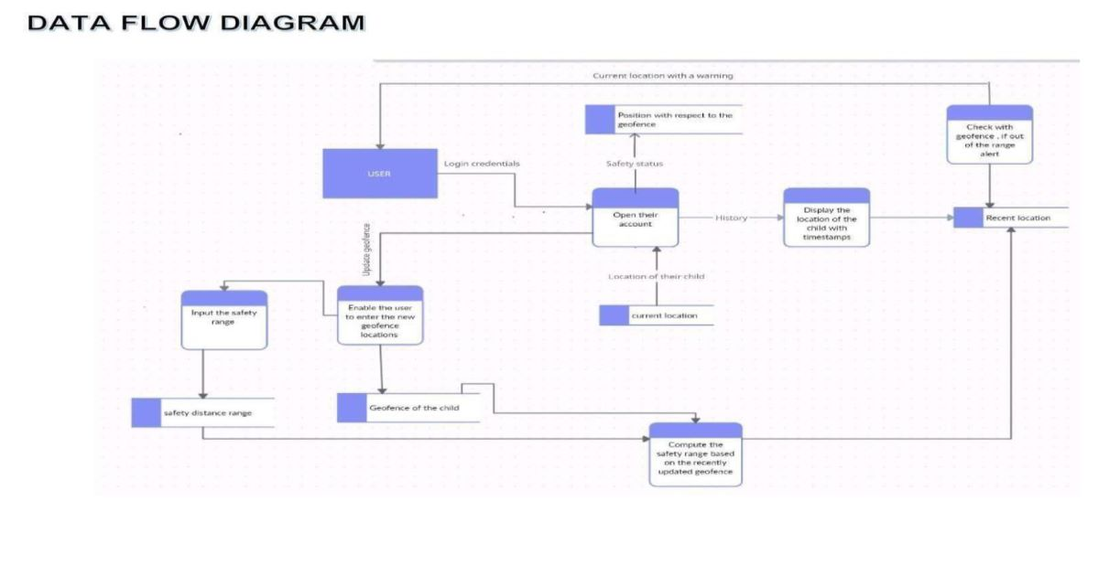

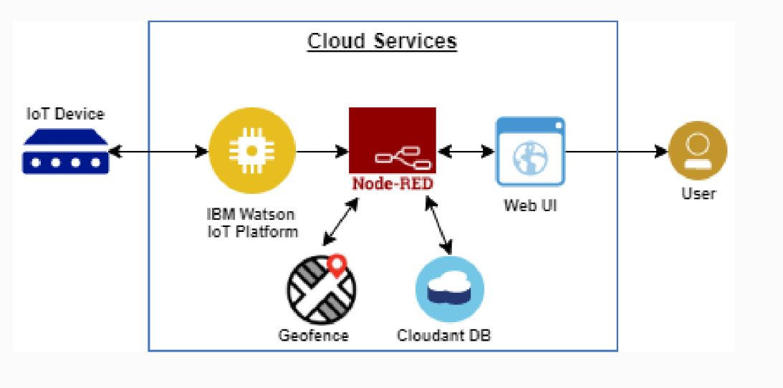

6.2SOLUTION AND TECHNICAL ARCHITECTURE:

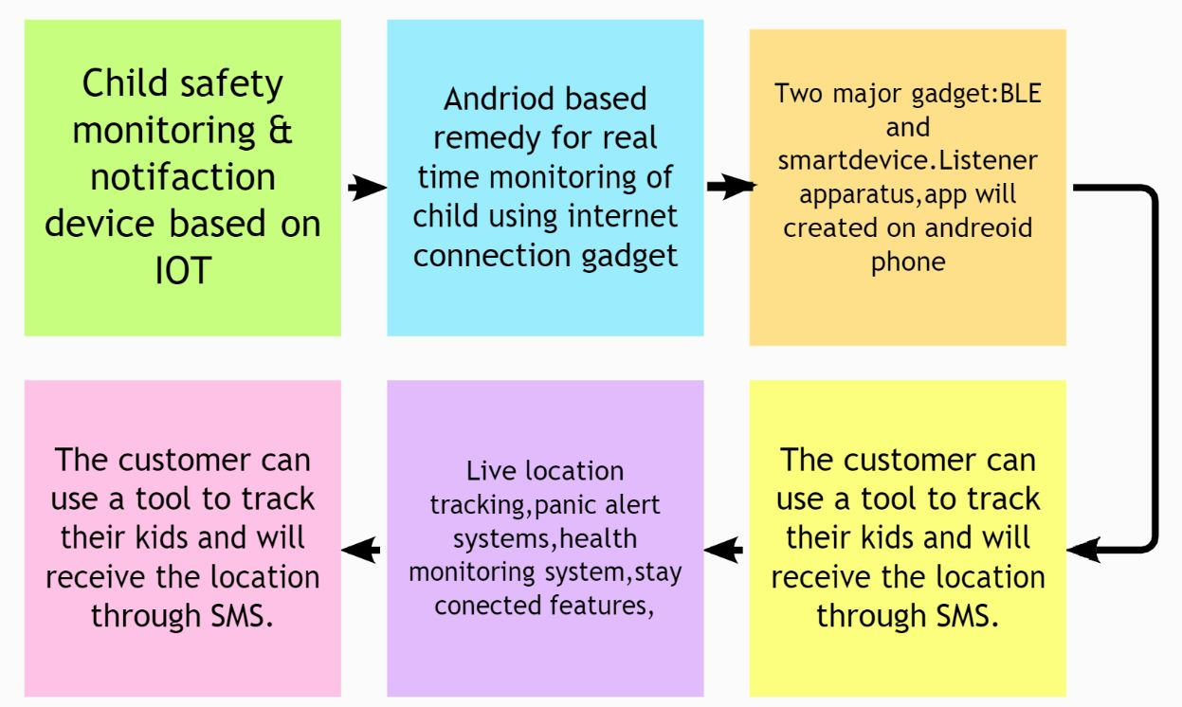

6.3USER STORIES:

|  |  |  |  |  |  |  |
| --- | --- | --- | --- | --- | --- | --- |
| User Type | Functional Requirement (Epic) | User Story Number | User Story / Task | Acceptance criteria | Priority | Release |
| Customer (Mobile user and web user) | Registration | USN-1 | As a user, I can register for the application by entering my email, password, and confirming my password. | I can access my account / dashboard | High | Sprint-1 |
|  |  | USN-2 | As a user, I will receive confirmation email once I have registered for the application | I can receive confirmation email & click confirm | High | Sprint-1 |
|  |  | USN-3 | As a user, I can register for the application through Facebook | I can register & access the dashboard with Facebook Login | High | Sprint-2 |
|  | Login | USN-4 | As a user, I can register for the application through Gmail |  | High | Sprint-1 |
| Customer Care Executive | Login |  | As I enter I can view the working of the application and scan for any glitches and monitor the operation and check if all the users are authorized. | I can login only with my provided credentials | Medium | Sprint3 |
| Administrator | Login |  | Maintaining making sure database containing locations secure accurate updated constantly. | I can login only with my provided credentials | High | Sprint3 |

7.Project planning and scheduling:

7.1sprint planning and estimation:

|  |  |  |  |  |  |  |
| --- | --- | --- | --- | --- | --- | --- |
| **Sprint** | **Functional Requirement (Epic)** | **User Story Number** | **User Story / Task** | **Story Points** | **Priority** | **Team Members** |
| Sprint-1 | Registration | USN-1 | As a user, I can register for the application by entering my email, and password, and confirming my password. | 4 | High | Mithra shree.K.R |
| Sprint-1 | Confirmation Email | USN-2 | As a user, I will receive a confirmation email once I have registered for the application | 4 | High | Ann Maria Fredy |
| Sprint-1 | Authentication | USN-3 | As a user, I can register for the application through Gmail and mobile app. | 4 | Medium | Swethapriyaa.S |
| Sprint-1 | Login | USN-4 | As a user, I can log into the application by  entering email & password | 4 | High | Tejaswini.G |
| Sprint-1 | Dashboard | USN-5 | As a user, I need to be able to view the  functions that I can perform | 4 | High | Mithra shree.K.R |
| Sprint | Functional Requirement (Epic) | User Story Number | User Story / Task | Story Points | Priority | Team Members |
| Sprint-2 | Notification | USN-1 | As a user, I should be able to notify my parent and guardian in emergency situations | 10 | High | Ann Maria Fredy |
| Sprint-2 | Store data | USN-1 | As a user, I need to continuously store my location data into the database. | 10 | Medium | Swethapriyaa.S |
| Sprint-3 | Communication | USN-1,2 | As a user, I should be able to communicate with my parents | 6 | Low | Tejaswini.G |
| Sprint-3 | IOT Device – Watson  communication | USN-1,3 | The data from IOT device should reach IBM Cloud | 7 | Medium | Mithra shree.K.R |
| Sprint-3 | Node RED- Cloudant  DB communication | USN-1,4 | The data stored in IBM Cloud should be properly integrated with Cloudant DB | 7 | High | Ann Maria Fredy |
| Sprint-4 | User – WebUI  interface | USN-1,5 | The Web UI should get inputs from the user | 10 | High | Swethapriyaa.S |
| Sprint-4 | Geofencing | USN-1,2,5 | The geofencing of the child should be done based on the geographical coordinates | 10 | High | Tejaswini.G |

7.2sprint delivery schedule:

|  |  |  |  |  |  |  |
| --- | --- | --- | --- | --- | --- | --- |
| **Sprint** | **Total Story Points** | **Duration** | **Sprint Start Date** | **Sprint End Date (Planned)** | **Story Points**  **Completed (as on Planned End Date)** | **Sprint Release Date (Actual)** |
| Sprint-1 | 20 | 6 Days | 24 Oct 2022 | 29 Oct 2022 | 20 | 29 Oct 2022 |
| Sprint-2 | 20 | 6 Days | 31 Oct 2022 | 05 Nov 2022 | 20 | 05 Nov 2022 |
| Sprint | Total Story Points | Duration | Sprint Start Date | Sprint End Date (Planned) | Story Points Completed (as on  Planned End Date) | Sprint Release Date (Actual) |
| Sprint-3 | 20 | 6 Days | 07 Nov 2022 | 12 Nov 2022 | 20 | 12 Nov 2022 |
| Sprint-4 | 20 | 6 Days | 14 Nov 2022 | 19 Nov 2022 | 20 | 19 Nov 2022 |

8.CODING AND SOLUTIONING:

import json

import wiotp.sdk.device

import time

myConfig = {

"identity":{

"orgId": "krs15q",

"typeId": "NodeMCU",

"deviceId": "12345"

},

"auth": {

"token": "vQez)XDErNEXZxtg-u"

}

}

client = wiotp.sdk.device.DeviceClient(config=myConfig, logHandlers=None)

client.connect()

while True:

name= "smartbridge"

#in area location

#latitude= 17.4225176

#longitude= 78.5458842

#out area location

latitude= 17.4219272

longitude= 78.5488783

myData={'name': name, 'lat':latitude, 'lon':longitude}

client.publishEvent(eventId="status", msgFormat="json", data=myData, qos=0, onPublish=None )

print("Data published to IBM Iot platform: ",myData)

time.sleep(5)

client.disconnect()

9.TESTING:

9.1 TEST CASE:

Test Scenarios:

1.) Verify the login cloud services

2.)Verify create a device in the IBM Watson IoT platform and get the device credentials.

3.) Verify wheather the python code is without error by running it

4.) Verify to create a node-red services

5.) Verify the events is stored in the database

6.) To create a web UI to interact with user

7.) To send SMS to the particular child's guardian.

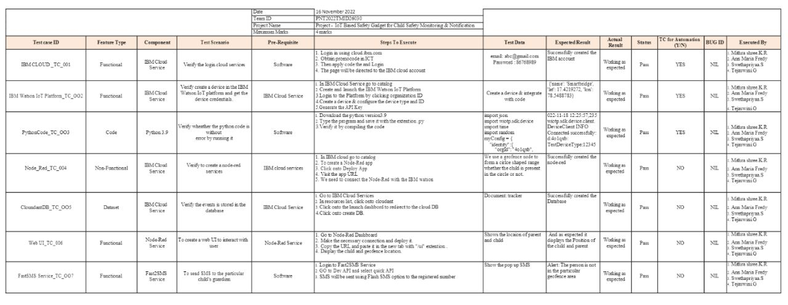

9.2 UAT testing:

A phase of software development in which the software is tested in the "real world" by the intended audience or business representative.

* Defect analysis:

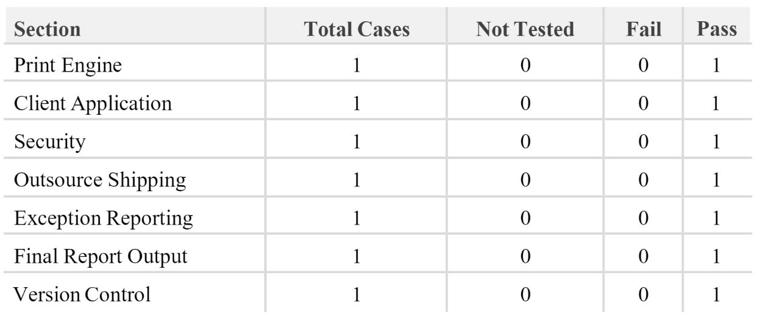

* Test case analysis:



10.ADVANTAGE AND DISADVANTAGE:

10.1 ADVANTAGE:

1. Staying conneted
2. Data accuracy
3. Efficiency
4. It can be used in any cell phone and doesn’t necessarily require an expensive smart phone.

10.2 DISADVANTAGE:

* High cost but once it is implemented the expenses can be reduced.

**11.CONCLUSION:**

The word Future resembles the word Children. As Dr. A.P.J Abdul Kalam’s words “Youngsters are the future pillars of one’s nation", today's children are tomorrow's youngsters, preserving their dreams and life for a better future is necessary. Therefore, each and every parent should take care of their own children, without letting them fall into the dark world of abuse, which entirely ruins them physically, mentally and emotionally, destroying our future. Hence, considering the importance of our future, our project makes it easy for parents to track their children and to visually monitor them on regular basis, which makes them ensure the safety of their children and reduces the rate of incidents of child abuse.

**12.FUTURE SCOPE:**

In our system, we automatically monitor the child in real time using Internet of Things, with the help of GPS, GSM, and Raspberry Pi. This system requires network connectivity, satellite communication, and high-speed data connection when we use a web camera and GPS to monitor. It is difficult to monitor when there occurs any hindrance to satellite communication or any network issue. There also occurs time delays in video streaming through the server. Hence in the future, these issues can be overcome by using the Zigbee concept or accessing the system without internet and using high-speed server transmission.

13.APPENDIX:

13.1Source code:

import json

import wiotp.sdk.device

import time

myConfig = {

"identity":{

"orgId": "krs15q",

"typeId": "NodeMCU",

"deviceId": "12345"

},

"auth": {

"token": "vQez)XDErNEXZxtg-u"

}

}

client = wiotp.sdk.device.DeviceClient(config=myConfig, logHandlers=None)

client.connect()

while True:

name= "smartbridge"

#in area location

#latitude= 17.4225176

#longitude= 78.5458842

#out area location

latitude= 17.4219272

longitude= 78.5488783

myData={'name': name, 'lat':latitude, 'lon':longitude}

client.publishEvent(eventId="status", msgFormat="json", data=myData, qos=0, onPublish=None )

print("Data published to IBM Iot platform: ",myData)

time.sleep(5)

client.disconnect()

13.2.GITHUB & PROJECT DEMO LINK:

GITHUB LINK:

https://github.com/IBM-EPBL/IBM-Project-1948-1658421116